Sure 👍 — here’s a clear point-by-point explanation of what the interactive_tutor_tk.py code (the one I made for you) does:

---

🧠 1. Purpose

It creates an AI-powered learning assistant that:

Reads semantic search results (conceptual text) from a file (Temp_semantic.txt).

Uses an Ollama reasoning model (like llama3, mistral, or deepseek-r1) to:

Explain the concept clearly.

Generate short quizzes/MCQs.

Evaluate answers and guide improvement.

Uses a Tkinter GUI to interact with the student.

Tracks learning progress and adapts explanations based on the student’s understanding.

---

📁 2. File Handling

It reads the text from a file (e.g. Temp_semantic.txt) which contains the semantic search output (the text chunks related to the current topic/module).

It loads/saves user progress (quiz scores, performance levels, etc.) in a JSON file (learning_progress_tk.json).

---

⚙️ 3. Ollama Reasoning Model Integration

It sends both:

The semantic content from the text file, and

The current module/query/progress info
…to an Ollama local API endpoint (http://localhost:11434/api/generate).

The model returns structured content:

Explanation: Simple, age-appropriate points.

Quiz questions: MCQs or fill-in-the-blanks.

Correct answers and feedback.

---

💬 4. Tkinter GUI (Graphical Interface)

It has a simple, multi-window flow:

1. Home/Load screen: lets the user select the semantic text file and start learning.

2. Concept display: shows the AI-generated explanation for the concept.

3. Quiz window: displays questions, lets the user type or select answers.

4. Result window: shows performance score and tailored feedback.

5. Adaptive retry: if score is low, the code sends a follow-up prompt to Ollama asking for simpler explanations and re-tests, and repeats until improvement.

---

📊 5. Learning Progress Tracking

Each concept/module’s progress is saved (e.g., concept mastered / needs improvement).

The tutor uses this data to adjust difficulty and pacing in future sessions.

---

🔄 6. Adaptive Learning Loop

Here’s the high-level flow:

Load concept text → Get AI explanation → Show to user
→ Give quiz → Evaluate answers → Update progress
→ If score < threshold → Re-explain in simpler terms + re-quiz
→ Repeat until concept mastered → Move to next module

---

🧩 7. Customizable Parts

You can modify:

The reasoning model name (e.g. llama3:8b, deepseek-r1).

The difficulty adaptation logic (score threshold, retry count).

The Tkinter interface (colors, font, layout).

The paths for the input/output files.

---

Would you like me to show a short diagram of how the data flows between the files, the model, and the GUI windows? It makes this loop easy to visualize.

The below is the execution of the semantic search algo:
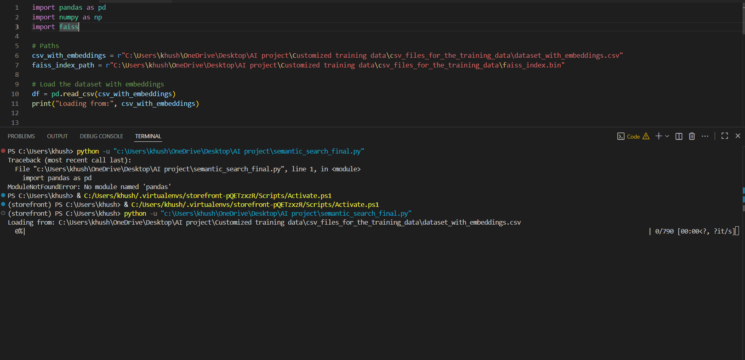
Similarly, all the other screenshots can be provided accordingly for each.
Very rough pseudocode:
Explanation of concept - in simple, pointers, easy for the student to grasp according to his/her age
Short quiz / MCQ / Fill in the blanks - evaluation for the concept - explanation to the wrong answer of the quizzes

You describe the progress indicator for the child's perception of a particular concept

if the score is unsatisfactory for the particular concept, explain in more detail, easy manner
Take a test again, using simpler terminologies and modified questions and make sure that the student improves his test score

repeat above steps until a part of the module has been covered
Repeat above steps until all the modules of a particular textbook are covered

++_+_+_+_+_+_+_+_+_+_+_+_

Good evening 🌆 — absolutely, let’s summarize everything you’ve done so far in your AI project pipeline so you have a clear overview.
Here’s the chronological summary of your work so far:

🧩 1. Project Setup
- You’re building a semantic search pipeline — basically, a system that can find relevant text snippets based on meaning (not just keywords).
- You’re using Python, Ollama (local model server), and FAISS (vector similarity search).
- Created a virtual environment (storefront) and installed necessary packages:
  - pandas, numpy, requests, faiss, tqdm, pymupdf (for reading PDFs).

📂 2. Data Extraction (Text Creation)
You wrote a script to extract text from PDFs and .txt files:
import fitz # PyMuPDF
import pandas as pd
from pathlib import Path

This script loops through your folder:
C:\Users\khush\OneDrive\Desktop\AI project guidlines and codes\Customized training data
and saves all extracted text into a single CSV file:
dataset_raw.csv

You later customized it to save inside:
C:\Users\khush\OneDrive\Desktop\AI project guidlines and codes\Customized training data\csv_files_for_the_training_data

🧠 3. Setting Up Ollama for Local Embeddings
- Installed Ollama — a local LLM runtime.
Pulled the nomic-embed-text model from Ollama’s library:
ollama pull nomic-embed-text

- This model generates text embeddings — numerical representations of meaning.
- Learned that:
You don’t run it with ollama run, but rather call its embeddings API:
http://localhost:11434/api/embeddings

  - You interact with it using a POST request.

🔢 4. Generating Embeddings
- You wrote a Python script (text_embeddings.py) to:
  - Load the extracted dataset (dataset_chunked.csv)
  - Send each text through Ollama’s embeddings API
  - Store the returned embeddings in the DataFrame
  - Save both:
    - dataset_with_embeddings.csv → full text + embeddings
    - faiss_index.bin → FAISS index file for efficient similarity search
Example snippet:
df['embedding'] = df['text'].progress_apply(get_embedding)
df.to_csv(output_csv_path, index=False)
index = faiss.IndexFlatL2(embedding_matrix.shape[1])
index.add(embedding_matrix)
faiss.write_index(index, faiss_index_path)

You also added tqdm to monitor progress visually — each row shows as a progress bar.

💾 5. Issues Encountered & Fixed
- Missing Python modules (like fitz, pandas) — fixed by installing them inside the correct virtual environment.
- Python path confusion — discovered your system was using C:\msys2\mingw64\bin\python.exe, fixed by calling the right Python path.
- FileNotFoundError — caused by wrong paths (...\\dataset_chunked.csv), fixed by using absolute paths.
- PermissionError — OneDrive locked your CSV file during writing; learned how to:
  - Close Excel/OneDrive sync,
  - Rename or move output files,
  - Run Python as admin.

🔍 6. Semantic Search Implementation
You prepared a function like this:
def search(query, k=5):
query_emb = np.array(get_embedding(query)).reshape(1, -1).astype('float32')
D, I = index.search(query_emb, k)
return df.iloc[I[0]][['text']]

- This takes a query (e.g., “Agro tourism is usually rural”),
- Embeds it using the same model,
- Searches for the k most similar entries in FAISS,
- Returns their corresponding texts.

✅ Current Status
You now have:
- ✅ Raw dataset extracted into CSV
- ✅ Ollama model (nomic-embed-text) installed
- ✅ Code for generating embeddings and building FAISS index
- ⚠️ A small issue writing the output CSV (PermissionError) — likely due to OneDrive
- 🚀 Ready to finalize the semantic search phase — just need to confirm your FAISS and CSV are generated properly.

Would you like me to make a visual summary (diagram) of your pipeline — from PDF → CSV → Embeddings → FAISS → Search — so you can document or present it easily?

